Homework 6

Asiqul Hoque

**Section 17 Lesson 2: Sorting Rows**

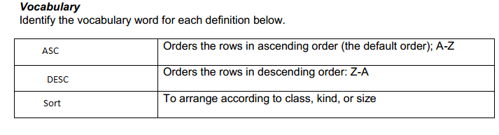

1.SELECT employee_id AS "Number", first_name, last_name  
FROM employees  
ORDER BY "Number";

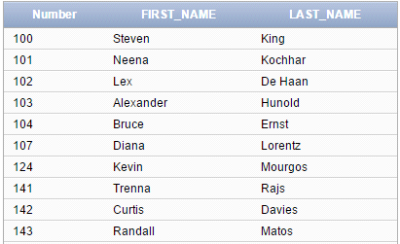

2. SELECT title, year  
FROM d_cds  
ORDER BY year, title;



3.SELECT title AS "Our Collection"  
FROM d_songs  
ORDER BY title DESC;



4.SELECT first_name, last_name, student_id, parkingnumber, year  
FROM students  
WHERE year = 'FIRST YEAR'  
ORDER BY last_name, first_name DESC;

5. SELECT department_id,last_name,manager_id  
FROM employees  
WHERE employee_id < 125  
ORDER BY department_id desc, last_name desc, manager_id desc;

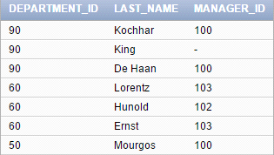

**Multiple Choice**

**1. C**

**2. C**

**3. A & D**

**4. A, B & C**

**5. C**

**6. D**

**7. ALL OF THEM**

**8. A, B & C**

**9. D**

**10. C**

**11. WHERE last_name LIKE 'St%';**

**12. any number thats less than 1900 or greater than 2100 will not be included**

**13.**

A. WHERE department_id NOT IN (101,102,103);

B. WHERE last_name = 'King'

C. WHERE start_date LIKE '05-MAY-98'

D. WHERE salary BETWEEN 5000 AND 7000

E. WHERE id != 10

**14. 410**

**Section 17 Lesson 3: Introduction to Functions**

**1.**

**A. single row**

**B. mutiple rows**

**C. single row**

**D. multiple rows**

**E. single row**

**F. single row**

**2.**

**AVG** = calculates and returns the average value from a set of numbers

**COUNT** = counts and returns the number of values from a set of values (Excluding Null values)

**MAX** = returns the highest value from a set of values

**MIN** = returns the lowest value from a set of values

**SUM** = returns the sum of a set of numeric values

**3.**

SELECT AVG(salary)

FROM employees;

Result: 8775

SELECT COUNT(salary)

FROM employees;

Result: 20

SELECT MAX(salary)

FROM employees;

Result: 24000

SELECT MIN(salary)

FROM employees;

Result: 2500

SELECT SUM(salary)

FROM employees;

Result: 175500